|  |
| --- |
| **Level 1 Digital Technologies** |
|  |
| **Digital Media Website Assessment Task (1.4)**  AS91880 (4 Credits) |

**Due date:** 20 March 2025 @ 15:15

**Submission guidelines:**

* This is an individual task.
* You have a specified amount of in-class time and out-of-class time to complete the learning and assessment for this standard. However, this time could be increased or decreased by your teacher to meet student needs and the requirements of your programme to complete it, in consideration of our current learning situation.
* All assessments must be handed in by the due date. Please refer to the NCEA student guideline 2023 for all assessment matters.

## Authentication

|  |  |  |  |
| --- | --- | --- | --- |
| This is to confirm that the work that I have submitted for marking is my own work.  Sign below when you submit your completed assessment in form marking. | | | |
| Signed by student: |  | Date Submitted: |  |

|  |  |  |  |
| --- | --- | --- | --- |
| Grade Verification – I have sighted my final grade and verify that it is correct. | | | |
| Signed by student: |  | Date Signed: |  |

I give permission for my assessment to be used for moderation purposes.

………………………………………….. Student Signature

## Index

1. Task 1 - Planning
   1. Purpose of website
2. Task 2 – Create the first page of the website
3. Task 3 – Effective use of design elements
4. Task 4 – Data Integrity and testing
5. Task 5 - Implications
6. Task 6 – Create and Test the other two webpages
7. Task 7 – Provide Evidence

# Task 1 – Getting Started

### Purpose of website

Write down the purpose of your website below. For example:

The purpose of my website is to showcase Asian food and provide opinions on all of them. My site will have a home page with a banner, boxes with different genres of food, eg. Noodles, buns meat. These will lead to pages that have more in depth reveiws of these foods.

### Mockup of website (example)

Add screenshots here of your mockups. Talk about the colours you used and the type of layout.

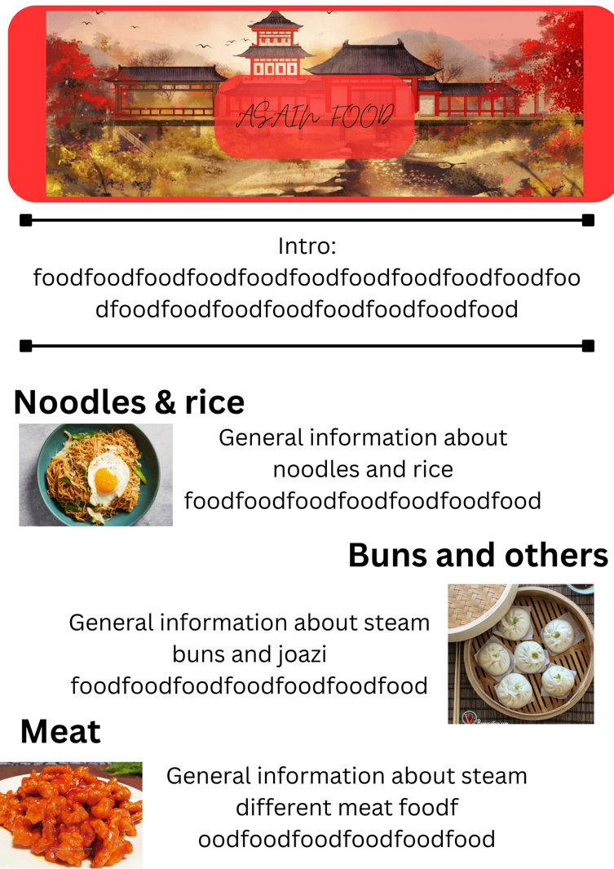

I used red colours as those are usually associated with Asia, I plan to use different shades of red in the linked websites on the food. I used alternating left and right images to use white space effectively and make it aesthetically pleasing. Feedback about mockups

Write down any feedback from other people here. For example:

When i showed it to Zach he told me to add borders around the text and images:

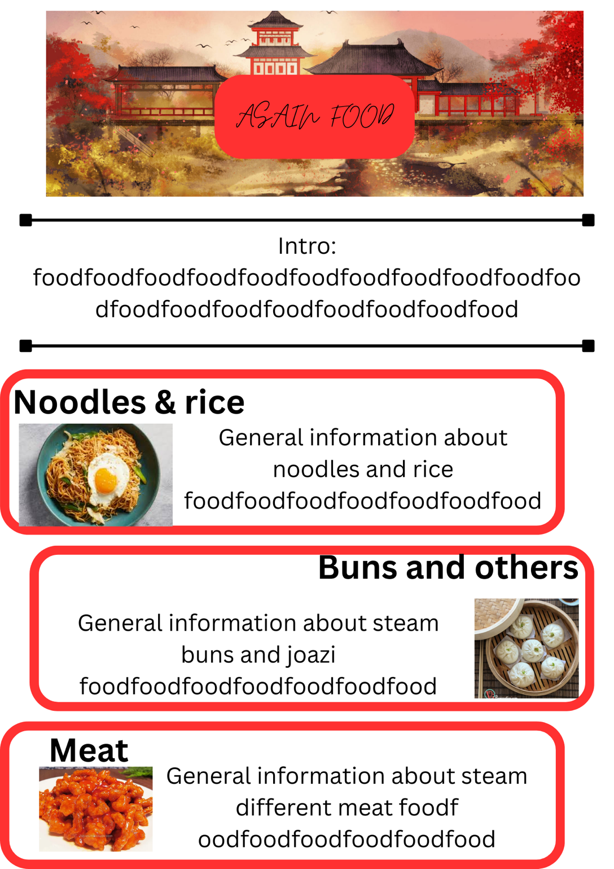

1. ***Remember you are not marked on how COMPLEX your website is for M/E, just how thoroughly you have gone through the testing/feedback/improvements cycle and that you’ve applied design elements effectively for a high quality, polished outcome.***

# Task 2 – Create the First Page of the Web Site

1. Use a text editor to create the first page of your web site. DON’T create the other pages yet as you need to make sure the first page is working correctly first.
2. Use a text editor to create the CSS file for your web page/web site.
3. **Versions:** At regular intervals (e.g. each day or couple of days) you should make a backup copy of your web folder/download the files from your IDE, so you can ‘roll back’ to previous versions if you make a mistake that’s hard to fix.
4. Add text and/or images related to the first page. Remember to use ALT tags for images.
5. Make your website look attractive.

# Task 3 – Effective Use of Design Elements

1. For excellence you need to apply design elements effectively. This would include some of:

|  |  |
| --- | --- |
| * 1. Consistent look and feel for all pages   2. Correct use of heading tags (H1, H2 etc)   3. Headings and subheadings formatted to stand out.   4. Links all in the same location on each page.   5. Links all at the top or in a location that is easy to access (don’t have to scroll to find them). | * 1. The site is easy to read (sufficient contrast, avoid dark text on dark background etc).   2. Effective use of repetition (images all styles the same way, same borders, same layout, same color themes).   3. The site looks pleasing to the eye.   4. Relevant text and images have been used and are grouped together. |

# Task 4 – Data Integrity and Testing

1. Check the first web page for **data integrity**, which would include checking some of the following:

|  |  |
| --- | --- |
| * 1. Text data typed in correctly without errors (proof reading)   2. No spelling mistakes   3. No grammar errors (capital letters, commas, full stops etc) | * 1. Correct image used in the correct place/page   2. ALT text matches image |

1. **Testing:** Document testing of your website. You can do this with **annotated screenshots** pasted into your document, or **screencast videos** saved into your One Drive folder. Make sure the sequence of testing is clear (e.g. date the images/videos or number them in order to show the progress). For M/E you should document your testing regularly, and document any feedback you get and improvements made from testing/feedback.
2. **Debugging:** Document any significant changes you make with screenshots/screencasts too, especially errors that come up, and how you solve them.
3. **Final Testing:** When your website is complete, record a screencast video of testing it thoroughly in at least 1 modern browser. Check the links work, media displays, and everything functions as intended. For M/E it’s a good idea to test it on different browsers and/or screen sizes.
4. **Test** that the first page of your website works and record your testing results. Include screen shots if necessary. For achieved you must do some testing. For Merit you must show that you have tested to improve the quality and functionality of the website. For Excellence you must do merit level testing, plus show that you did testing throughout the creation of the website, which would include having before and after screen shots and testing not done at one point in time. Excellence student would include evidence how they refined their website because of their testing (e.g: testing found a problem which was then fixed, retested, re-fixed to get it right). Testing could include any of the following:

|  |  |
| --- | --- |
| * 1. All pages required by client have been included   2. All images and text required by client have been included   3. Text is readable (not dark text on dark background, or difficult to read font etc)   4. Images actually display   5. Images display in the correct size   6. Images are free of unwanted elements (eg: remove unwanted stop sign in the background etc)   7. Images have ALT text   8. Page displays as intended   9. Links work (for all pages)   10. Elements function correctly (title works, clear hierarchy of headings and subheadings H1, H2 etc) | * 1. Colours work well together   2. Layout is presentable and works as expected   3. All pages have a consistent look and feel (heading, links etc are all in the same place on each page, each page has the same colour scheme etc)   4. Validated HTML and CSS (so HTML and CSS is correct)   5. Tested in at least two browsers to ensure both display the web site as expected   6. All files are saved in one folder (with subfolders if needed)   7. Files and folders named correctly (no spaces, no capitals, well named etc)   8. All files have an extension (.html, .css, .jpg etc) |

# Task 5 – Implications

1. **Describe** any implications relevant to your website and its creation. For merit you also need to **address these implications** in your website and record how you addressed the implications. Choose at least 1 bullet from any 3 boxes below.

|  |  |
| --- | --- |
| **Social**   * Is the site suitable for the intended audience (images and text targeted to right age group etc) * What does the client want? Does the site deliver? | **Cultural**   * Culturally appropriate image and text, especially if international audience * Is the content age appropriate |
| **Legal**   * Did you avoid breaking copyright * Did you get permission to use images, text * Did you simply copy and paste from somewhere else * Did you reference where you got your text/images from if necessary | **End-user considerations**   * What does the user want, and can you provide it * Who is using your site – old people need bigger fonts, young people will view on phones * Appropriate content for gender, age, ethnic groups viewing your site |
| **Ethical**   * Site avoids racist, sexists content * Has appropriate words/content | **Aesthetics**   * Making something beautiful, giving it a pleasing appearance |
| **Accessibility**   * Use ALT text for blind users * Use colour blind friendly colours * Don’t rely on colour to convey information (eg: Red = error, use an icon or text as well) * Use of limited colours (for colour blindness) * Consideration of dyslexia (special font, left aligned text, spacing around text and images to separate them out) | **Sustainability and future proofing**   * Compressed images to reduce server space and bandwidth * Using up-to-date HTML CSS * Avoiding depreciated tags * Using external CSS to let you maintain site easily * Responsive design for small and large screens * Comments in code * Validating my code to ensure it is correct * Semantically correct HTML & CSS |
| **Privacy**   * Don’t use photos of people without permission * Don’t include private information | **Health and safety implications**   * Ensuring the project isn’t too big so won’t overwhelm or wear you out * Taking regular breaks (rest eyes, rest hands from typing, circulate blood etc) |
| **Functionality**   * What is the purpose of the website, and does it achieve this? (Trade Me should let you buy and sell, so do these functions work?) * Do the main navigational links match up to the main objectives of the site (eg: Trade Me needs buy and sell links at the top, not terms and conditions) * Do the links all work as expected, are any dead links? * What does the client want? Does the site deliver? * Do the images all appear, do they have ALT text? * Do any videos work properly? | **Usability**   * Consistent look and feel for all pages * Links at top and in same place for each page * Navigational menus don’t cover important information on page * Hierarchy of headings, headings stand out * Scaleable content, testing on multiple devices * Organized content (easier to find things on the site) * Readable font * Using search feature to find information, or site map * Is the information on the site correct and up to date |

# Task 6 – Create and Test the Other 2 Web Pages

1. Make sure your first page is looking as intended. Spend more time getting the first page right before you start on the other 2 pages.
2. **Create** the other 2 web pages (to make a 3 paged, linked web site).
   1. Make sure the images and text on each page relate to the topic.
   2. Make sure all links work. This includes links on the other 2 pages (not just the first page).
3. Check these pages for errors and **test** that the other 2 pages work as intended. Excellence students need to show evidence they tested, refined, tested and refined.

# Task 7 – Provide Evidence

1. Make sure you have all of your files saved as these will be your evidence that you created a web site.

**Testing**

|  |  |  |
| --- | --- | --- |
| What am I testing | Outcome of the test | Any fixes |
|  |  |  |
|  |  |  |
|  |  |  |
|  |  |  |

1. Make sure you have provided evidence of describing and addressing any relevant implications.